Lecture 5
CO1: Apply the knowledge about the concepts of probability and statistics for the computer applications.
CO3: Apply the knowledge about basic ideas of statistics including measures of central tendency, correlation and regression.
Measures of Dispersion
The averages are representatives of a frequency distribution. But they fail to give a complete picture of the distribution. They do not tell anything about the scatterness of observations within the distribution. Suppose that we have the distribution of the yields (kg per plot) of two paddy varieties from 5 plots each. The distribution may be as follows
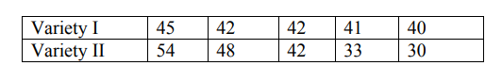
It can be seen that the mean yield for both varieties is 42 kg but cannot say that the performances of the two varieties are same. There is greater uniformity of yields in the first variety whereas there is more variability in the yields of the second variety. The first variety may be preferred since it is more consistent in yield performance.
Form the above example it is obvious that a measure of central tendency alone is not sufficient to describe a frequency distribution. In addition to it we should have a measure of scatterness of observations. The scatterness or variation of observations from their average are called the dispersion. There are different measures of dispersion like the range, the quartile deviation, the mean deviation and the standard deviation.
Characteristics of a good measure of dispersion
An ideal measure of dispersion is expected to possess the following properties
- It should be rigidly defined
- It should be based on all the items.
- It should not be unduly affected by extreme items.
- It should lend itself for algebraic manipulation.
- It should be simple to understand and easy to calculate

Range
This is the simplest possible measure of dispersion and is defined as the difference between the largest and smallest values of the variable.
- In symbols, Range = L – S.
- Where L = Largest value.
- S = Smallest value.
In individual observations and discrete series, L and S are easily identified.
In continuous series, the following two methods are followed.

Method 1
L = Upper boundary of the highest class
S = Lower boundary of the lowest class.
Method 2
L = Mid value of the highest class.
S = Mid value of the lowest class
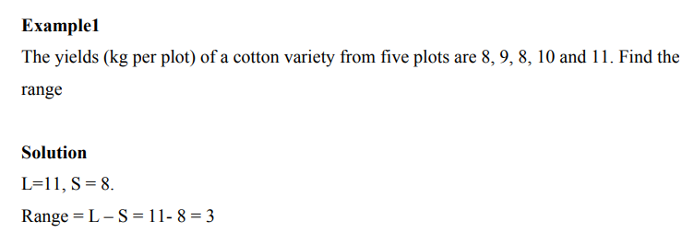
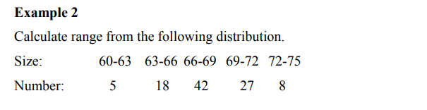
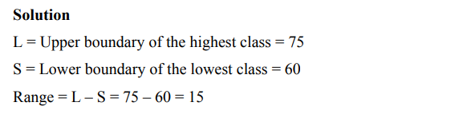

Merits and Demerits of Range
Merits
- It is simple to understand.
- It is easy to calculate.
- In certain types of problems like quality control, weather forecasts, share price analysis, etc.,
range is most widely used.
Demerits
- It is very much affected by the extreme items.
- It is based on only two extreme observations.
- It cannot be calculated from open-end class intervals.
- It is not suitable for mathematical treatment.
- It is a very rarely used measure.

Practice Questions
- The weight of 11 forty-year-old med were 148, 154, 158, 160, 161, 162, 166, 170, 180, 195 and 236 pounds. If the heaviest man is omitted, what is the percentage change in the range?
TEXT BOOKS
- T1 = H. K Dass, Higher Engineering Mathematics, S. Chand Publishers,3rd revised edition.2014.
- T2 = B.S. Grewal, Higher Engineering Mathematics, Khanna Publishers,42th ed.2013, New Delhi.
- T3= N. P. Bali and Manish Goyal, A textbook of engineering Mathematics, Laxmi Publications, Reprint 2008.

REFERENCE BOOKS
- R1=R. K. Jain and S. R. K. Lyenger, Advanced Engineering Mathematics ,3rd Edition Narosa Publishing House ,2004,New Delhi.
- R2 =B. V. Ramana Advanced Engineering Mathematics, McGrawHill, July2006, New Delhi.
- S.P.Gupta,StatisticalMethods,S.Chand&Sons,2017,NewDelhi,ISBN9789351610281Insiders’Guide

Video Lecture :
https://www.youtube.com/watch?v=wuQSeGYQ0ms&list=PL86hgHi3F9FoYVwLPFjVd0fvhPMLIcp0m

